1 Login to Ubuntu Server

Run ifconfig to demonstrate the IP is the correct one.  
Run netstat to demonstrate all open ports   
Run netstat -tulpn to demonstrate all listening ports.

\* note the >> appends to the CSV File

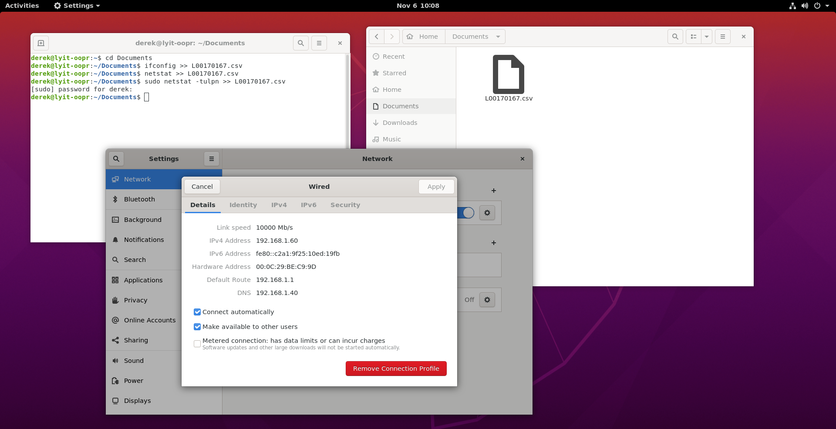



2 Run Script against Server

